Big Muddy Brew ‘N Que 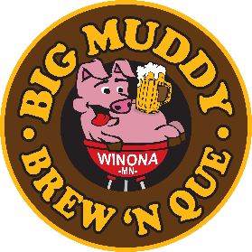

art and Craft Fair contract September 3rd & 4th 2022
Who: Artists and crafters from the Winona region
When: September 3rd & 4th noon – 6pm
Where: Levee Park, Downtown Winona
Space Requirements: 10’ Wide x 12’ Deep (Tent is no required but recommended)
Rates: Early Bird $25 (Due by July 31, 2022); Registration after August 1: $30
Contact: Jenna Lubinski, intern@winonachamber.com

Please fill out attached form and return to:
(Email forms welcome)
Winona Area Chamber of Commerce
Attn: Big Muddy Art and Craft Fair
902 E. 2nd St.
Winona, MN 55987
Check, cash or credit card accepted. Make checks payable to Winona Area Chamber of Commerce.
Questions? Contact us at:
Tel: 507-452-2272 Email: info@winonachamber.com Fax: 507-454-8814

Big Muddy Brew ‘N Que Art and Craft Fair Contract
Please provide us with details of your display (rates listed below):
Artist/Business Name:
Contact Name:
Product description:
_______________________________________________________________________________________
Email:
Phone Number:
Website (to be linked on Big Muddy page): ___________________________________________________
Do you wish to be added to a wait list if the spaces are already full? Circle one: Yes No
Payment Type (Circle One): Cash Check Credit Card
Credit Card Number:
Expiration Date/Security Code:
*If you have a photo or logo you wish to be used in website promotion, please email a jpg or png file to intern@winonachamber.com*
Return completed forms to:
(Email forms welcome)
Winona Area Chamber of Commerce
Attn: Big Muddy Art and Craft Fair
902 E. 2nd St.
Winona, MN 55987
Check, cash or credit card accepted. Make checks payable to Winona Area Chamber.
Questions? Contact us at:
Tel: 507-452-2272 Email: info@winonachamber.com Fax: 507-454-8814

